

Scratch and Brown Base Coat Stucco
Portland Cement Plastering
09 24 00

DIVISION 9
2

Product No. 1139
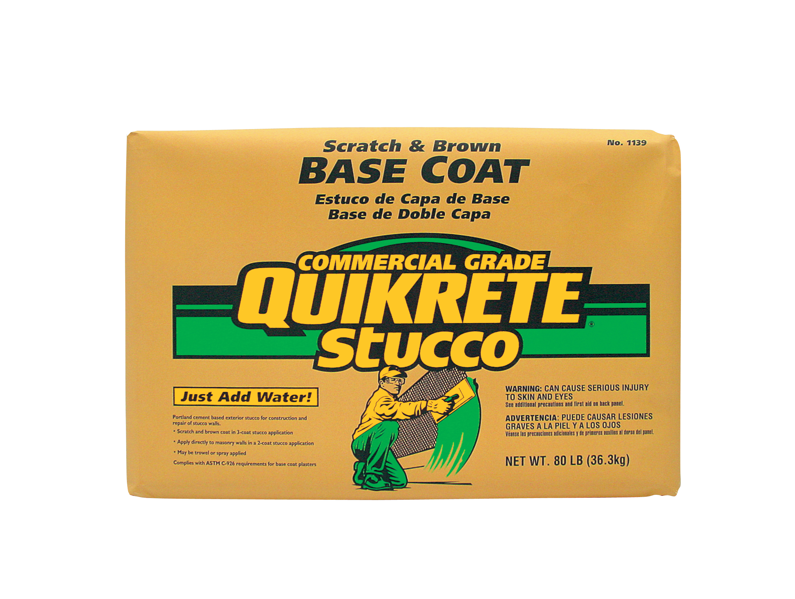
PRODUCT DESCRIPTION
QUIKRETE® Scratch and Brown Base Coat Stucco is a Portland cement-based stucco designed to be used as the scratch and/or brown coat in a 3-coat stucco application, or the first coat in a 2-coat application

PRODUCT USE
QUIKRETE® Scratch and Brown Base Coat Stucco is manufactured
as a complete product requiring only the addition of water. Extended board life and water-stop versions of this product are available.

SIZES
• QUIKRETE® Scratch and Brown Base Coat Stucco - 80 lb (36.3 kg) bags

YIELD
• Each 80 lb (36.3 kg) bag of QUIKRETE® Scratch and Brown Base Coat Stucco will yield approximately 0.83 cu ft (23 L) of mixed plaster.

TECHNICAL DATA
APPLICABLE STANDARDS
ASTM International - ASTM C926 Standard Specification for Application of Portland Cement Based Plaster

PHYSICAL/CHEMICAL PROPERTIES
QUIKRETE® Scratch and Brown Base Coat Stucco meets ASTM C926 requirements for Portland cement-based plaster.

INSTALLATION
MIXING
• Blend approximately 1.5 gal (5.7 L) of water per 80 lb (36.3 kg) bag
• Place the water in the mixer, then slowly add the QUIKRETE® Scratch and Brown Base Coat Stucco
• Mix for 2 - 3 minutes, or until a trowelable consistency is achieved
• Add additional amounts of water if necessary

APPLICATION
QUIKRETE® Scratch and Brown Base Coat Stucco is intended for use over galvanized expanded metal lath or solid bases such as masonry, cast-in-place or pre-cast concrete. Installation over these
surfaces shall be in accordance with ASTM C926 and local building codes.

QUIKRETE® Scratch and Brown Base Coat Stucco may be applied with a trowel or sprayer according to typical stucco techniques.
• Mix only as much QUIKRETE® Scratch and Brown Base Coat Stucco as can be applied in 1 hour. Variation in water addition will affect color uniformity.
• Do not apply additional water during application. Proper rewetting of base coats and finish treatment will eliminate the need for additional water. Avoid overlapping fresh stucco over previously dried areas as this will result in a lack of color uniformity
* Refer to www.quikrete.com for the most current technical data, MSDS, and guide specifications

CURING
Provide sufficient moisture to permit continuous hydration of the cementitious materials and minimize cracking. The most effective procedure and frequency will depend on climate and job conditions. Under normal conditions, moist curing is accomplished by applying a fine fog spray of water generally twice daily in the morning and evening. Care must be exercised to avoid erosion damage to plaster surfaces. This procedure should be repeated for several days following stucco application. During hot and dry conditions, additional precautions may be necessary, including more frequent misting or the erection of barriers to deflect sunlight and wind.

Note - QUIKRETE® Finish Coat Stucco (#1201) can be applied over QUIKRETE® Scratch and Brown Base Coat Stucco in accordance with ASTM C926 and local building codes.

PRECAUTIONS
Do not apply when temperatures are expected to fall below 40ºF (4ºC) within a 24 hour period.

WARRANTY
The QUIKRETE® Companies warrant this product to be of merchantable quality when used or applied in accordance with the instructions herein. The product is not warranted as suitable for any purpose or use other than the general purpose for which it is intended. Liability under this warranty is limited to the replacement of its product (as purchased) found to be defective, or at the shipping companies’ option, to refund the purchase price. In the event of a claim under this warranty, notice must be given to The QUIKRETE® Companies in writing. This limited warranty is issued and accepted in lieu of all other express warranties and expressly excludes liability for consequential damages.

The QUIKRETE® Companies
One Securities Centre
3490 Piedmont Rd., NE, Suite 1300, Atlanta, GA 30305
(404) 634-9100 • Fax: (404) 842-1425

